**→ Image filters using discreate Fourier transform (DFT) :**

1. **Read our image :**

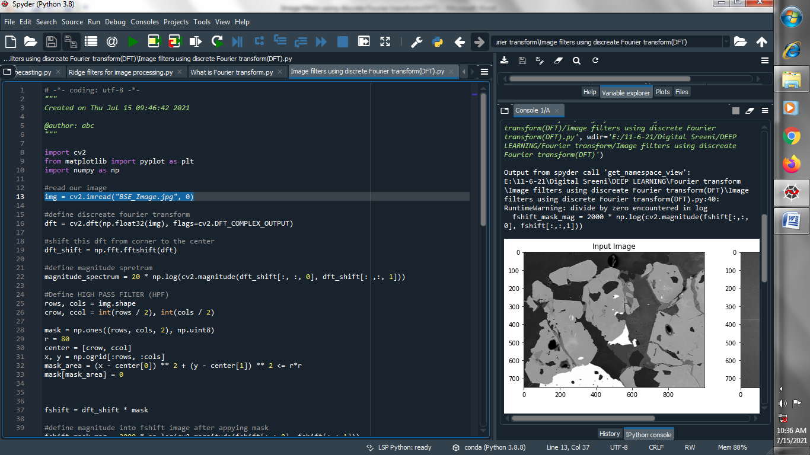

1. **define discreate fourier transform :**

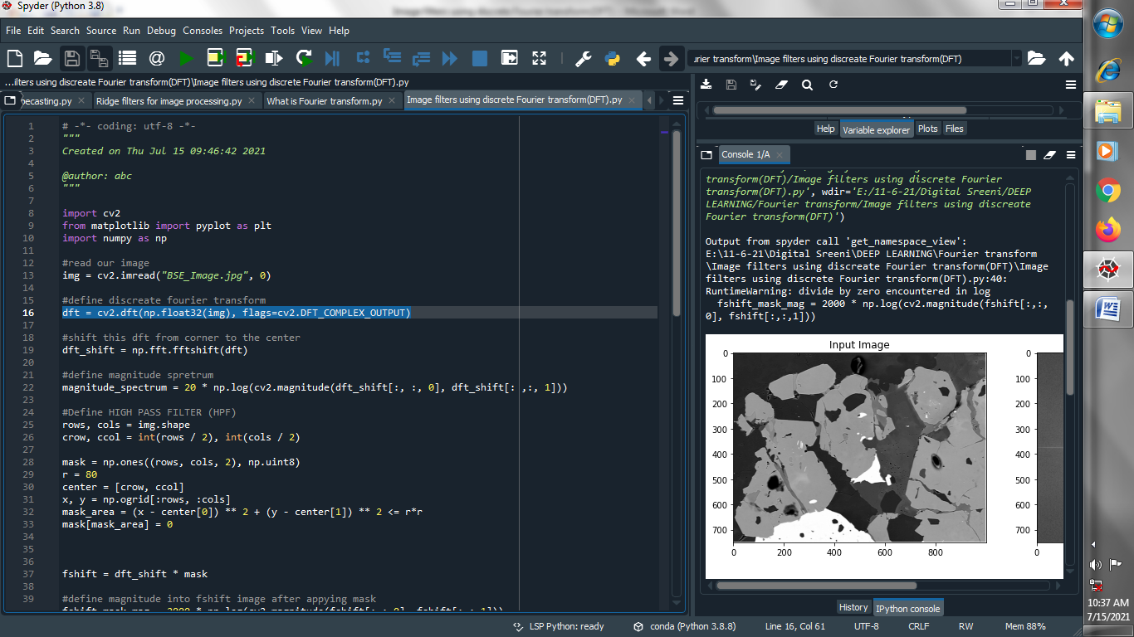

1. **shift this dft from corner to the center :**

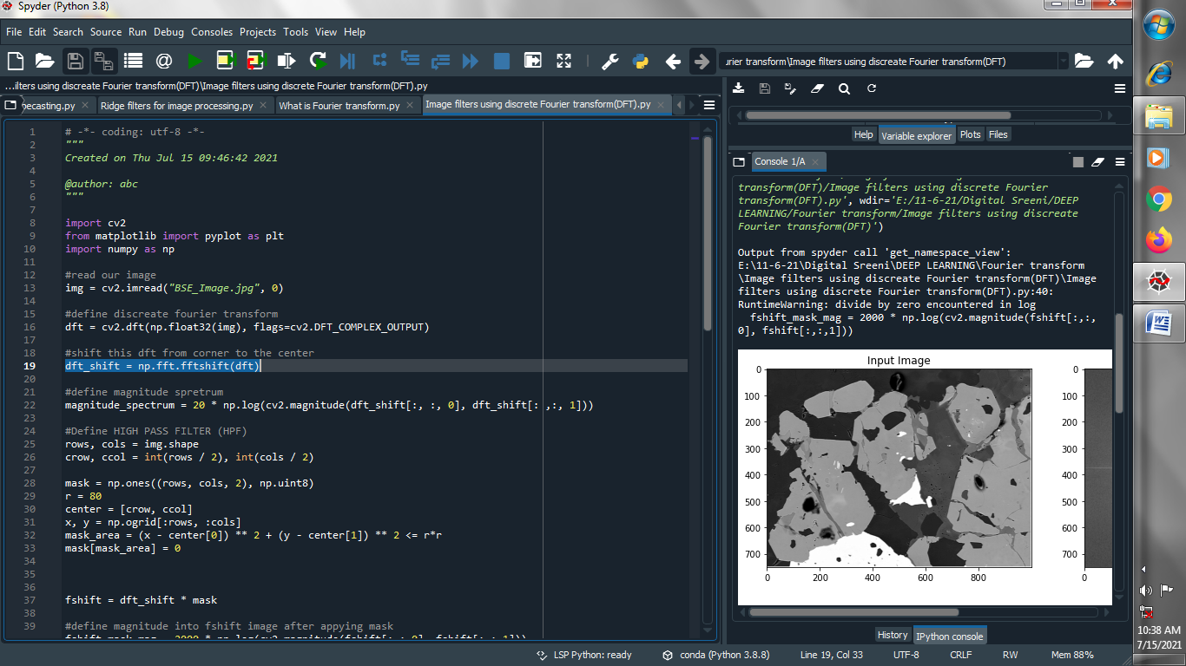

1. **define magnitude spretrum :**

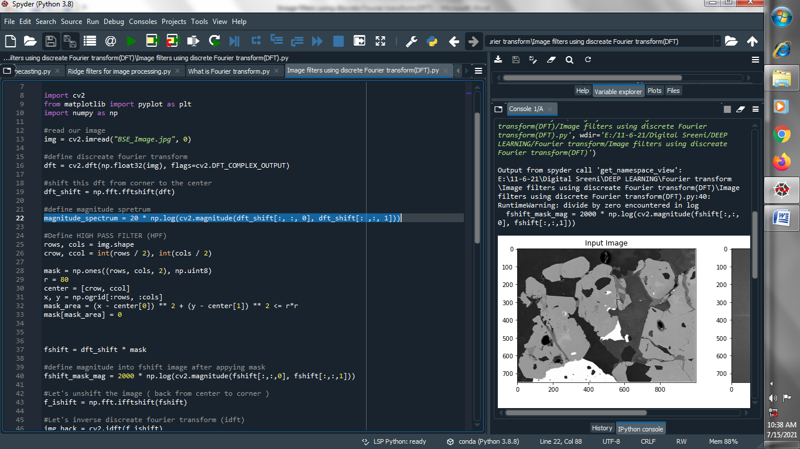

1. **Define HIGH PASS FILTER (HPF):**

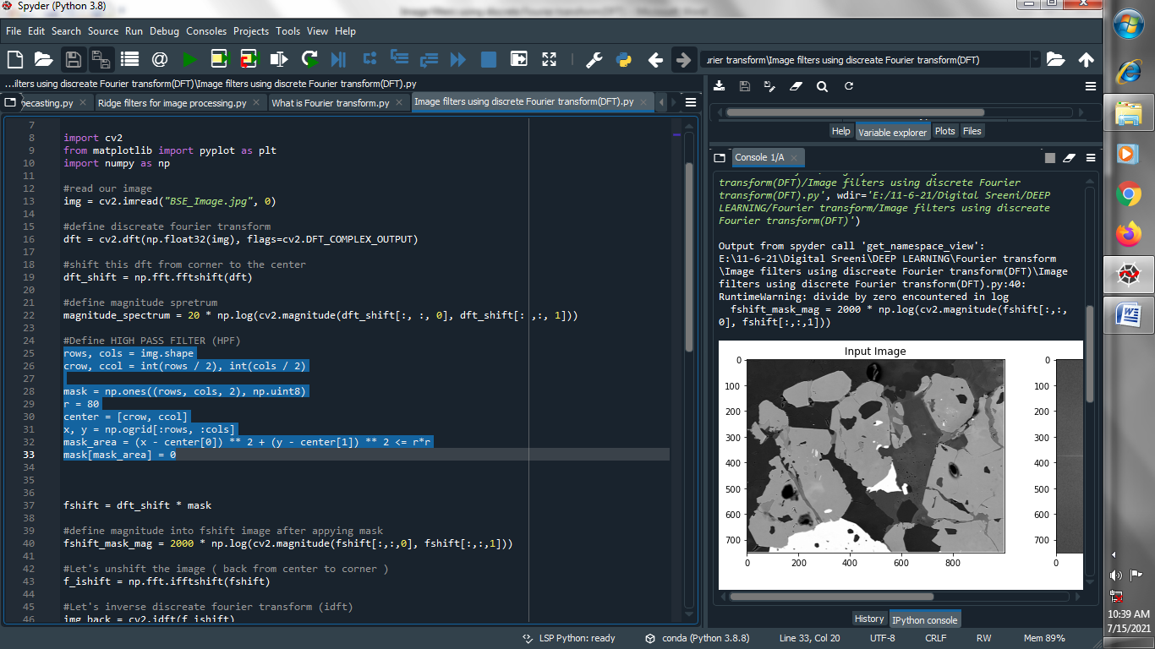

1. **Apply mask :**

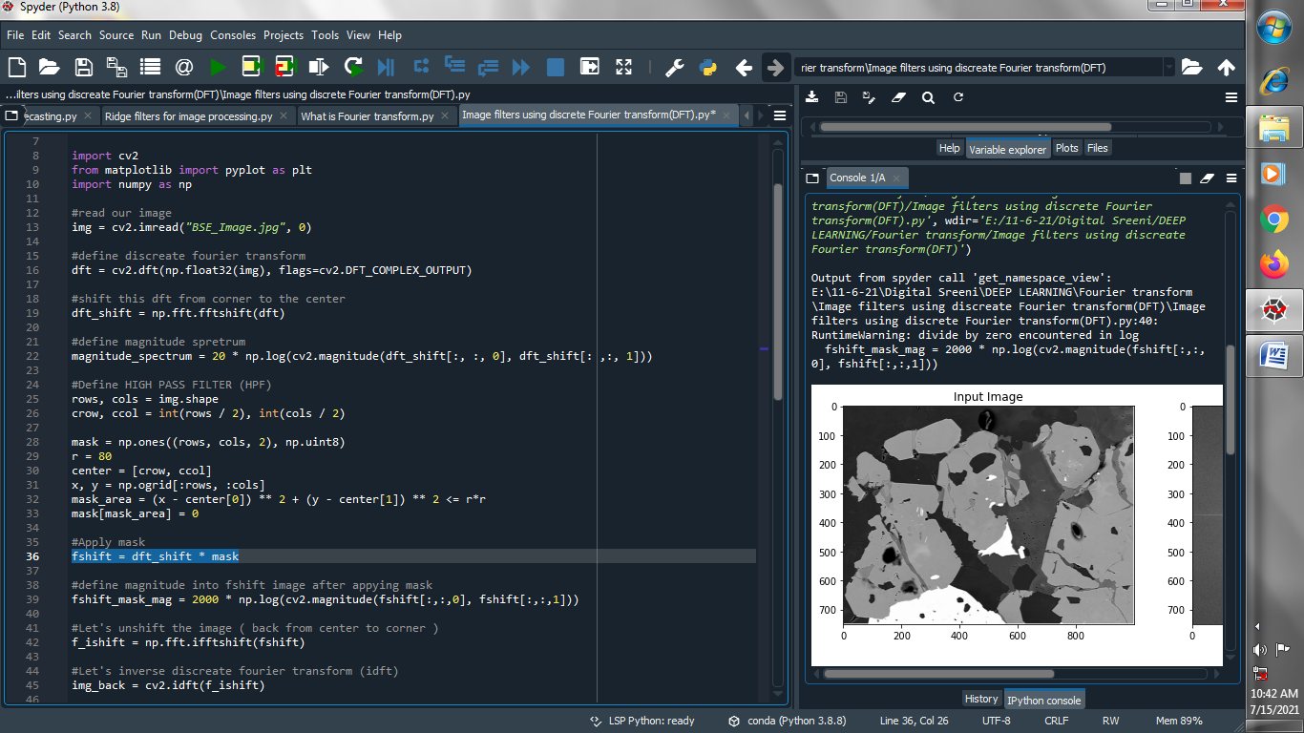

1. **define magnitude into fshift image after applying mask :**

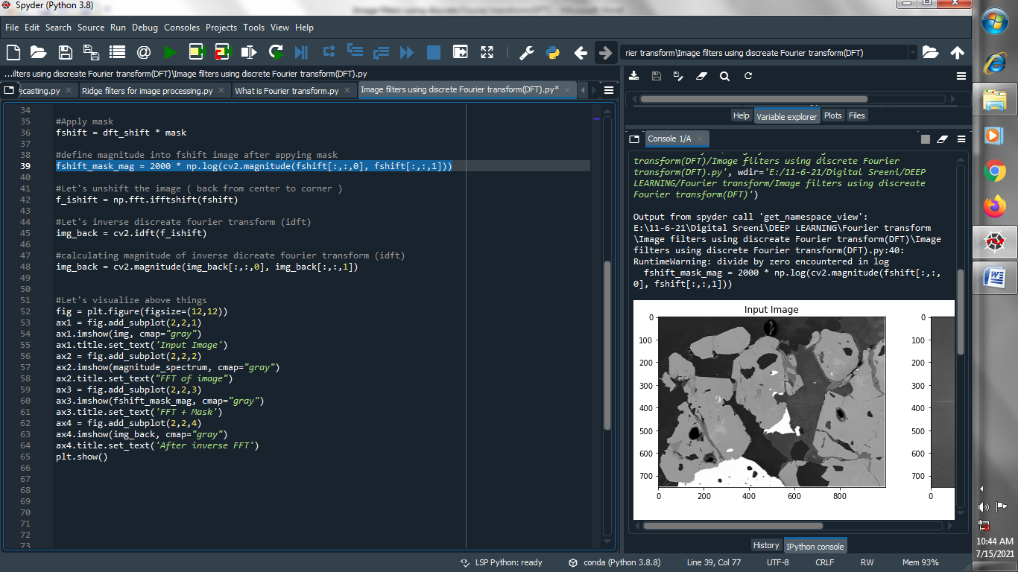

1. **Let's unshift the image ( back from center to corner ) :**

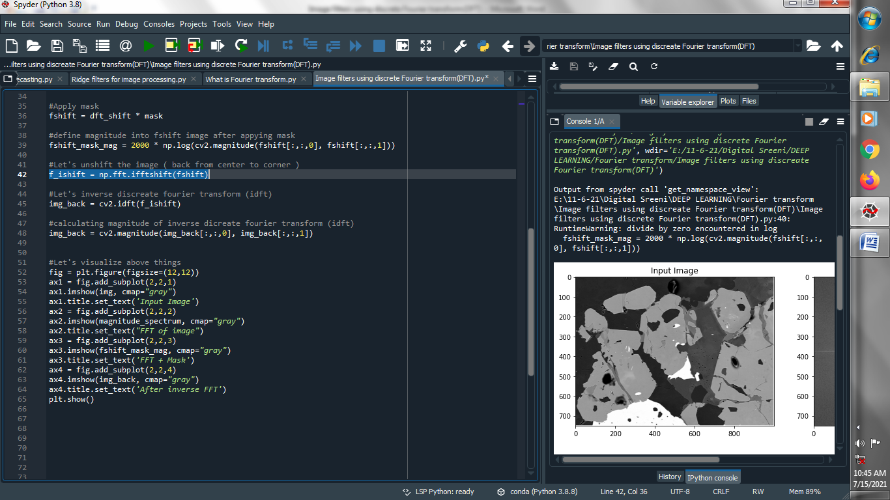

1. **Let's inverse discreate fourier transform (idft) :**

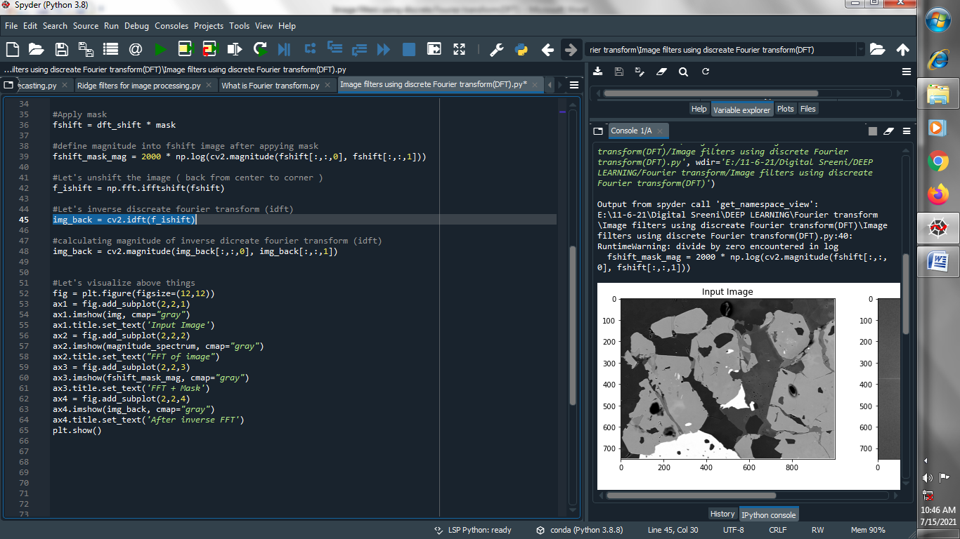

**(10) calculating magnitude of inverse dicreate fourier transform(idft) :**

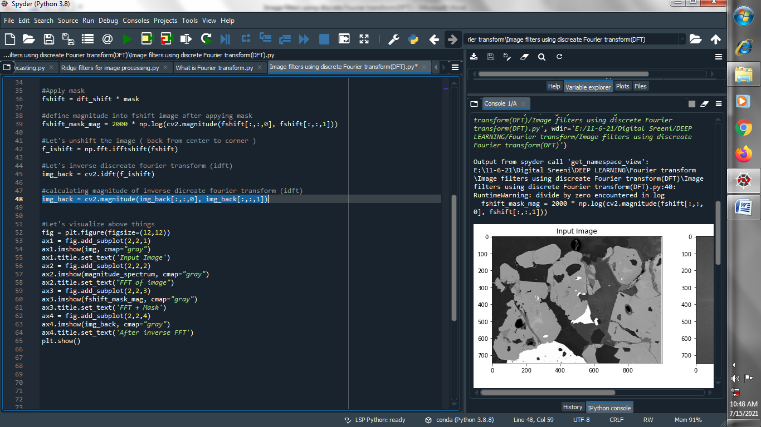

**(11) Let's visualize above things :**

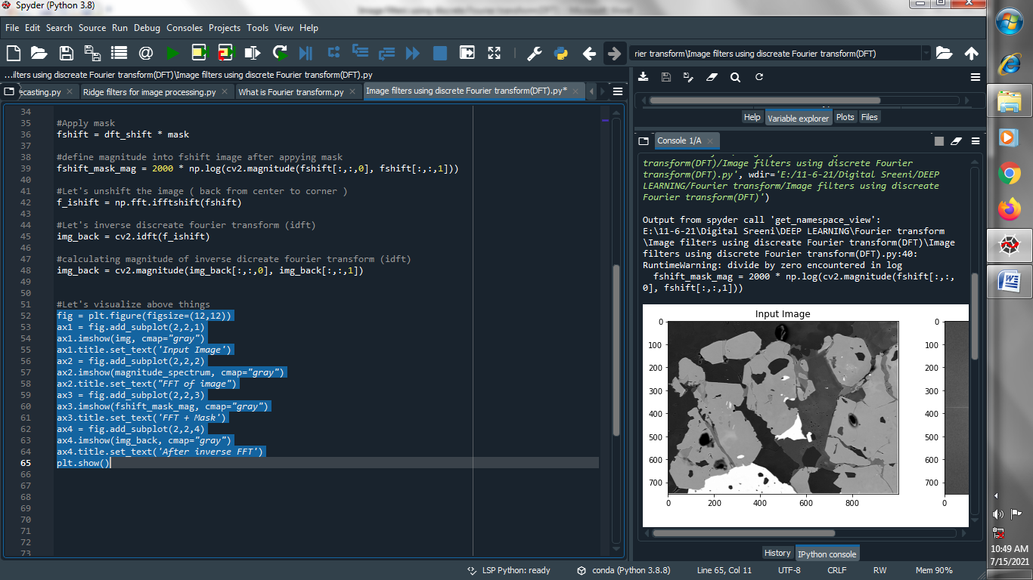

**Output :**

